Table of Contents

1 Infinite Dungeoner 4

2 Design History 4

3 Game Overview 4

3.1 Game Concept 4

3.2 Feature Set 4

3.3 Genre 5

3.4 Target Audience 5

3.5 Game Flow Summary 5

3.6 Look and Feel 5

3.7 Project Scope 6

3.7.1 Number of locations 6

3.7.2 Number of levels 8

3.7.3 Number of NPC 8

3.7.4 Number of weapons 8

4 Gameplay and Mechanics 9

4.1 Gameplay 9

4.1.1 Game Progression: 9

4.1.2 Mission/challenge Structure 9

4.1.3 Puzzle Structure 10

4.1.4 Objectives 10

4.1.5 Play Flow 10

4.2 Mechanics 11

4.2.1 Physics 11

4.2.2 Movement 11

4.2.3 Objects 12

4.2.4 Actions 12

4.2.5 Combat 13

4.2.6 Economy 14

4.3 Screen Flow 15

4.3.1 Screen Flow Chart 15

4.3.2 Screen Description 15

4.4 Game Options 17

4.5 Replaying and saving 17

4.6 Cheats and Easter Eggs 18

5 Story, Setting and Character 18

5.1 Story and Narrative 18

5.1.1 Back story 18

5.1.2 Game Progression 18

5.1.3 License Considerations 19

5.2 Game World 19

5.2.1 General look and feel of the world 19

5.2.2 Area #1 – Entrance of Dungeon 19

5.2.3 Area #2 – Final Boss 20

5.2.4 Area #3 – Gem Room 20

5.2.5 Area #4 - Catacombs 21

5.2.6 Area #5 – Sorcery 21

5.3 Characters 22

5.3.1 Character #1 – The general 22

5.3.2 Character #2 – The scientist 23

5.3.3 Character #3 – The thief 23

6 Technical 24

6.1 Target Hardware 24

6.2 Development hardware and software 24

6.2.1 Development hardware 24

6.2.2 Development software 24

6.3 Development procedures and standards 24

6.3.1 Development procedures 24

6.3.2 Development standards 25

6.4 Game Engine 25

6.5 Network 25

6.6 Scripting Language 25

7 Interface 26

7.1 Visual System 26

7.1.1 HUD 26

7.1.2 Menus 26

7.1.3 Rendering system 26

7.1.4 Camera 26

7.1.5 Light models 26

7.2 Control system 27

7.3 Audio 27

7.4 Music 27

7.5 Sound effects 27

8 Artificial Intelligence 27

9 Game Art 27

10 Management 27

10.1 Schedule 27

10.1.1 Prototype 1 – October and November, 2022 27

10.1.2 Prototype 2 – December, 2022 28

10.1.3 Prototype 3 – January, 2023 28

10.1.4 Prototype 4 – to be continued 28

10.2 Version control 28

10.3 Test 28

11 Appendices 28

11.1 Material source 28

11.2 References 29

11.2.1 General references 29

11.2.2 Udemy courses for dungeon game development 29

11.3 Project video log: 29

# Infinite Dungeoner

# Design History

October – November, 2022: (1) Write game design report. (2) Determine the game settings

December, 2022: (1) Custom editor window for map system. (2) Create game maps. (3) Create 3 game characters and basic operations.

# Game Overview

## Game Concept

Infinite Dungeoner is a top-down bullet hell shooter roguelike game. The player takes control of a character that needs to reach the deepest place of the dungeon to get the guarding gem back. Players can shoot and switch among the guns equipped during the game process. To against the enemy’s fire, players can hide behind the walls or just dodge the bullet (Maybe they can press shift to perform a dodge roll to dodge the bullets or use some consumable items in the future).

The dungeon is made up of many levels (Excluding starting point and final boss, maybe more levels in future). The map layout, enemies, weapons, and rewards of each level are generated by the program. To defeat enemies, the player needs to use the weapons obtained in the chest room and boss battles. Weapons range from conventional pistols and rifles, to more fantastic firearms such as Excalibur, Rocket Launcher, and Magic wand. Players can obtain gold coins from defeated enemies, which can be spent in stores. Each level of the dungeon has a random boss. Only after killing the boss, the players can be allowed to enter the next level. The game has a permadeath system. If the player dies, they need to start again from the first level.

The final boss the player meets for the first time is specially designed, and all final bosses after that will be the shadow version of the player’s last playthrough. This ties into the game’s backstory.

As the player passes the dungeon multiple times, they may meet some NPCs and have access to more varieties of weapons in the dungeon. The NPCs may be store owners or provide some clues for players to dig out the truth of the game.

## Feature Set

In a time of technology and magic, the magical stone protecting the world is stolen by some bad guys. The world is hanging on a thin thread. It all depends on you retrieving the magical gem. In this game, you can explore the dungeon, collect amazing weapons, dodge bullets, and defeat the boss.

## Genre

(1) Role Playing, (2) Roguelike, (3) Single Player, (4) Offline, (5) Bullet hell, (6) Top-down perspective.

## Target Audience

Everyone 10+ (some violence included in the game). May attract people who like dungeon exploration and rouge-like.

## Game Flow Summary

Players use WASD to move and use their mouse to aim and shoot. As shown in Soul Knight and The Binding of Isaac, there are doors in four directions in each room. The doors connect to a corridor. Moving between levels is via a one-way vortex portal.

## Look and Feel

Top-down perspective, 2D, pixel. Here are some pictures of relevant games:

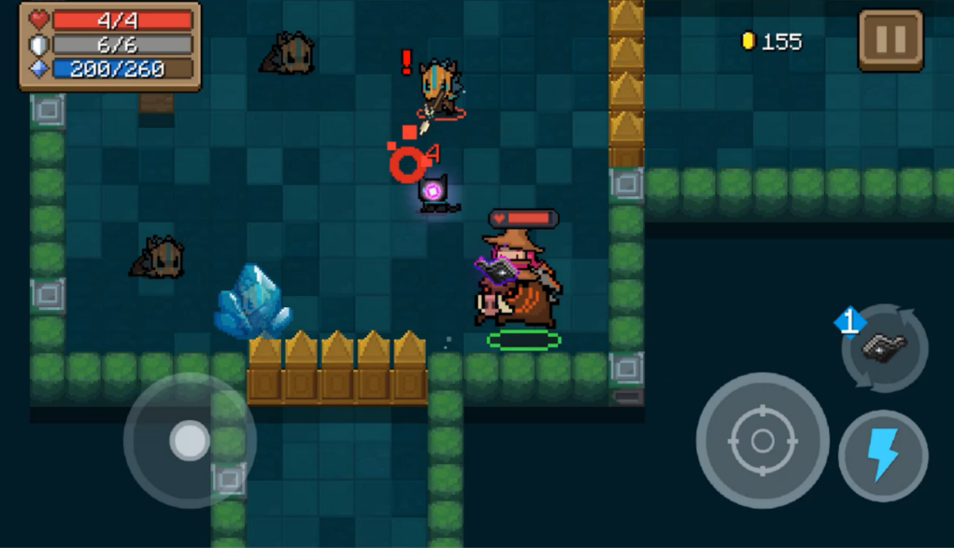

Figure Soul Knight

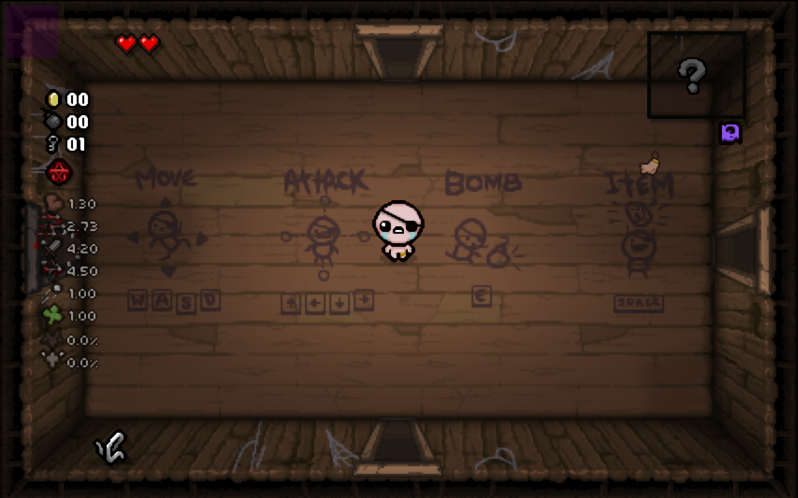

Figure The Binding of Isaac

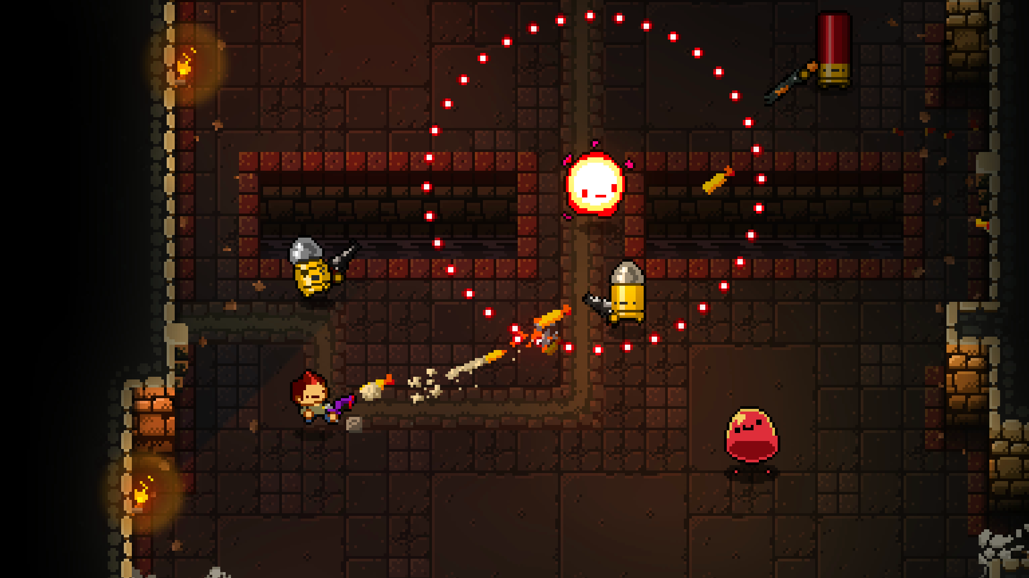

Figure Enter the gungeon

## Project Scope

### Number of locations

Locations will be procedurally randomly generated based on their characteristics and make up the map for each floor.

As the level increases, the size of the map will also increase, which is intuitively reflected in the increase in the number of rooms that must pass from the starting point of each level to the level boss room.

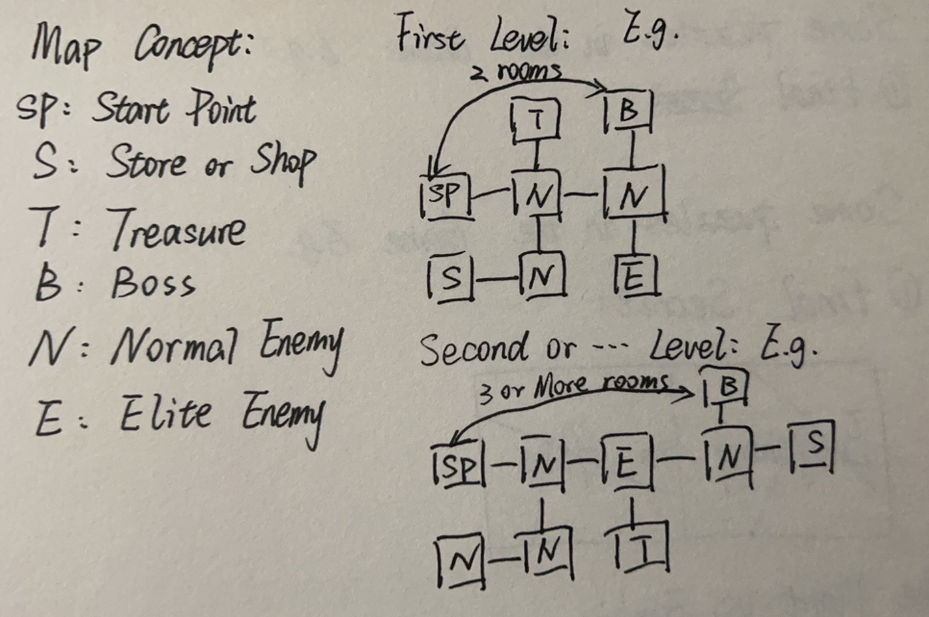

Figure Concept image of the map (locations of each level)

1. Start point – Entrance of the dungeon, also the main start menu of the game.

Start point for each level: The player always stands in the centre of the start point room whenever they enter a new level.

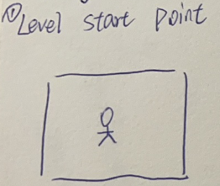

Figure Concept image of “start point”

1. Corridor – Connecting two rooms.

Small room (Normal enemy, low probability of getting equipment from an enemy)

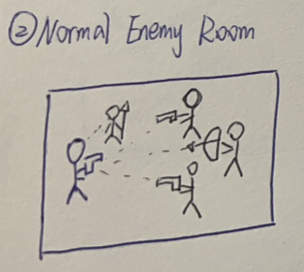

Figure Concept image of “small room”

(3) Medium room (Harder than small room, high probability of getting equipment from an enemy)

(4) Large room (Harder than medium room, higher probability of getting equipment from an enemy)

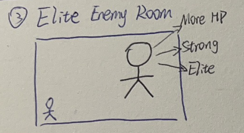

Figure Concept image of “large room”

(5) Chest room (Free to obtain weapons or some gold coins)

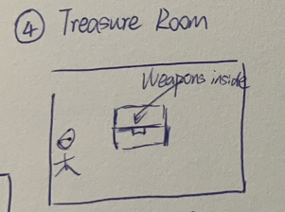

Figure Concept image of “chest room”

(6) Boss room (In earlier versions, the boss may be a regular enemy with higher hp and larger size)

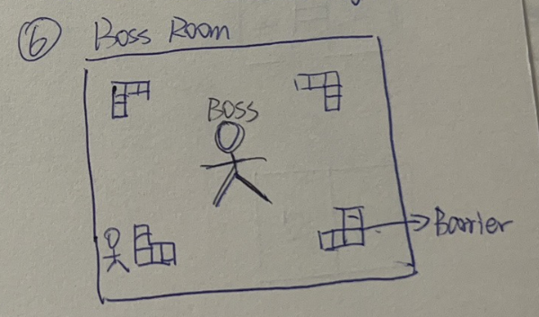

Figure Concept image of “boss room”

### Number of levels

(1) Entrance to the dungeon, also the main menu of the game.

(2) First level

(3) Second level

(4) Third level

(5) Fourth level

(6) Fifth level

(7) Sixth level

(8) Final Boss level

(9) The Gem Room

### Number of NPC

Currently, no NPC

### Number of weapons

Guns: Pistol, Rifle, Rocket launcher, Bow, Shotgun, Machine gun, etc.

Magic: Fireball, Iceball, lighting, etc.

Fantastic: Excalibur, one punch, etc. (This is reserved for making Easter eggs.)

# Gameplay and Mechanics

## Gameplay

### Game Progression:

**Simple Version**: In this game, players must reach the bottom of the dungeon, defeat the all-level bosses and take back the magic gem. During the process of getting to the bottom, players need to complete each level and for each level, they need to complete each room. After entering any room with enemies, the doors will be closed. Only after all enemies have been eliminated, the doors of the room can be unlocked. Usually, a series of such rooms are experienced before reaching the level boss’s room. After defeating the level boss, they can enter the next level. Players will repeat this until they meet the final Boss. If they defeat the final Boss, they can enter the gem room to get the gem back, at this time game is successful.

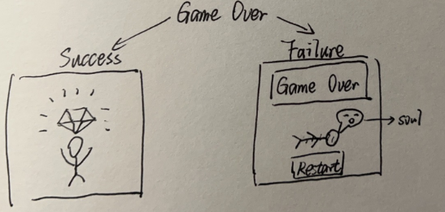

Concept image of two game results

However, if players lose all health points before they enter the gem room, they need to restart the game from the entrance of the dungeon with nothing.

**Complex Version**: As the number of clearances and the number of dungeon expeditions increases, Players will gradually collect some special pieces of paper, which will form a sentence when they are fully collected. This will tell the players the truth about the dungeon, and the fully assembled note has magical powers that allow the player to resist the vortex generated after taking the gem back, thus putting the player into the final trip mode.

In the final trip mode, players can learn the truth about the dungeon, and they need to defeat the real final boss.

### Mission/challenge Structure

After entering any room with enemies, the doors of the room will be locked. Players need to defeat all enemies with their weapons, and after defeating all enemies, doors will open. So that players can enter the next room/level.

### Puzzle Structure

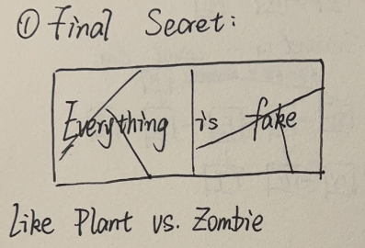

Figure Concept of secret paper

Part of the pieces of paper can be obtained after completing the puzzle in some special rooms. Defeating the final boss usually gets the first piece. The paper looks similar to the PVZ’s paper (Plants vs. Zombies)

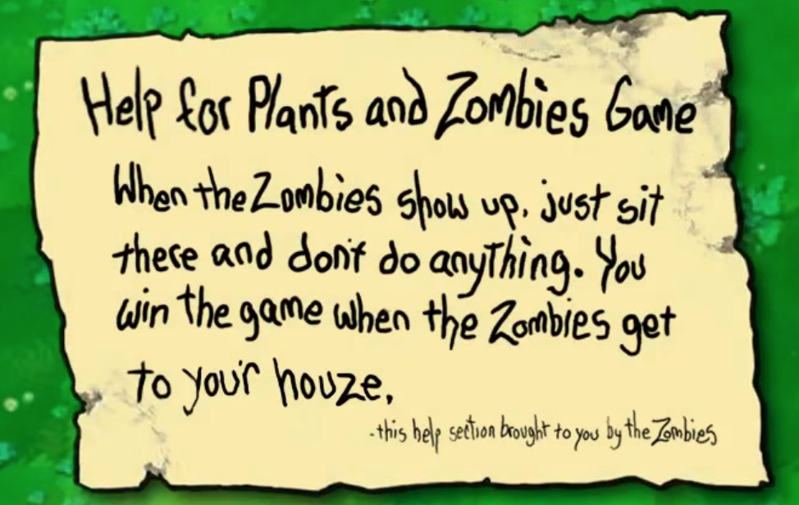

Figure The secret paper has the similar style as PVZ

After collecting all the pieces of paper, players can get the spell to wake up from the infinite loop. They need to enter the spell after entering the gem room but before getting the gem. To prevent cheating, the program itself will check whether the player has collected all the pieces, which means that the final puzzle will not be triggered if the pieces are not collected

### Objectives

Simple Version: Defeat the enemies, defeat the final boss, and get the gem back.

Complex Version: Find the truth, defeat alien invaders, and save the real world

### Play Flow

**Simple Version:** The player will start the game at the entrance of the dungeon. After entering the dungeon, there is the first level. The player will stand at the centre of the start room of the first level, and then they can enter the next room and defeat enemies inside. Sometimes they can obtain some weapons and gold coins from enemies, they can use the gold coins to buy some restoration potions, new weapons and ammo in the store. Finally, they will find the boss room on the first level. After they defeat the boss, a portal will exist so that they can enter the next level. They will repeat the process of clearing each level before they reach the bottom level – the final boss. After defeating the final boss, they can enter the gem room, to get the gem back. When they put the gem back on the pedestal, a vortex will suddenly appear and suck them in. At this time, game success will pop up. And next time, after a period of black screen, the player will wake up at the entrance of the dungeon. Also, if the player dies in the dungeon, after the game over popping up, they will wake up at the dungeon entrance.

**Complex Version:** The player enters the spell against the vortex so that they start the final trip mode. An animation will play, and then the player will wake up from the experimental cabin, and the researchers will tell them the truth. After this, the player can choose a part of the weapons they owned when they completed the dungeon just now to fight with the real enemies.

## Mechanics

### Physics

This is a 2D game, so it doesn’t reflect the height difference and hence the bullet won’t fall but they still have the range, if they reach the range they will disappear. Others are basically the same as the real universe, if the player moves and shoots, the bullet will have the same deflection. Some weapons also have accuracy issues, there may be a certain degree of bias. Also, some obstacles in the game can resist bullets, such as walls, and wooden boxes. But they can be destroyed if they are fragile like wood products or shrubs.

### Movement

#### General Movement

The player can use “WASD” to control the character to move up, down, left and right.

The player can use the right mouse button to scroll. Cannot shoot while scrolling but being invulnerable

#### Other Movement

Some enemies with weapons will move left and right while keeping a certain distance from the player. Regarding unarmed enemies, they will move straight towards the player at a certain speed.

### Objects

#### Picking Up Objects

Sometimes enemies will drop some gold coins, players need to get close to them to attract them. The player can press “E” to pick up the weapons.

#### Moving Objects

There is currently no consideration for adding movable objects to the game.

### Actions

#### Switches and Buttons

No interactive switches and buttons during gameplay. There are only some basic interactive buttons at the beginning and end of the game, or when the game is paused.

#### Aiming and Shooting

The player can use their mouse to aim, the cursor is the crosshair. And they can use the left mouse button to shoot. The camera moves with the player's cursor, allowing the player to see distant enemies.

#### Picking Up, Carrying and Dropping

The player can hold 6 weapons at the same time, they can press number 1 to number 6 or use the mouse wheel to switch weapons. If the player already has 6 weapons, when they pick up a new weapon again, they will drop the weapon on their hands.

The player cannot carry any potions, just drink them or leave them on the ground. They can come back to use the potions for restoration before they enter the next level.

#### Talking

The player can press “E” to talk with NPCs like researchers or shop owners, but NPCs will only tell some jokes or useless information.

If the player starts the final trip mode, they will see the animation, and after the animation, there will be a conversation with the researchers in the form of dialogue. Here is an example:

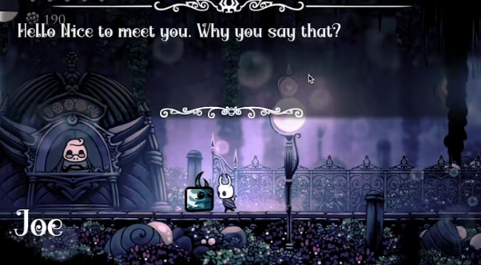

#### Reading

There may be some signs in special rooms with hints about the puzzle. The player can press “E” when they near the signs to read the words written on the sign.

### Combat

Since the player can carry many types of weapons and the types of enemies are different. Here we divide into many cases for discussions.

Bullet: The player and enemies with guns can fire bullets, usually enemies’ bullets are red and players’ bullets can be every kind of colour except red. This allows the player to distinguish which bullets are their own and which are the enemies’.

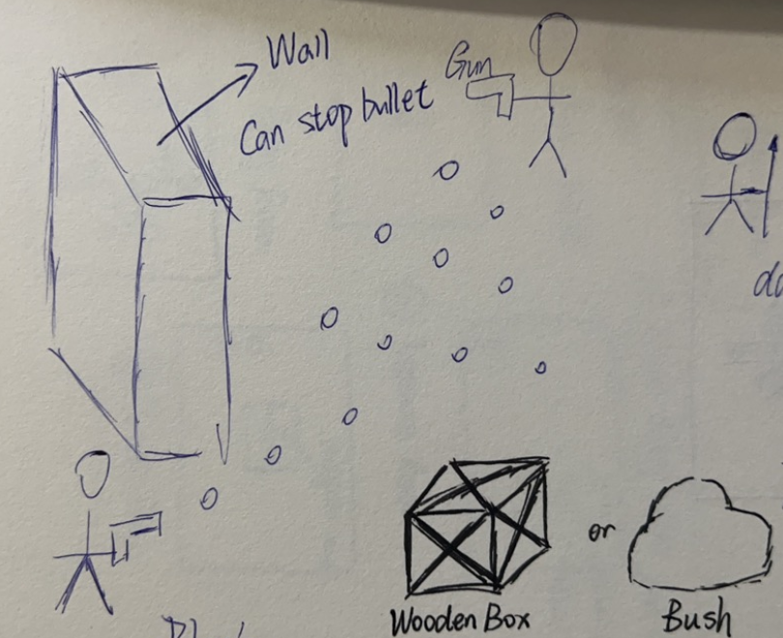

Figure Concept image of bullet and barrier

Barrier: There will be some barriers in the room where they can resist bullets. But if they are fragile like wooden boxes or shrubs, they will be destroyed if they are hit many times. (It depends on the damage of the bullet and the type of barrier)

Enemy: Enemies have their own health points. The player can use weapons to attack them. If their hp drops to 0, they will die and be removed from the game. Notice that some enemies are holding melee weapons and some are even unarmed. They will gradually approach the player, but usually only a little bit faster than the player. And unarmed enemies can charge so that they can approach the player quickly or directly hit the player to cause damage.

Weapon: The player can use the ranged weapon to fire bullets. Some special weapons have amazing-style bullets

### Economy

The player can obtain gold coins from enemies or the chest chest. They can use gold coins to buy some potions, weapons and ammo in the store. Usually, normal enemies will drop 1-3 gold coins and elite enemies will drop 10-20 gold coins, the level boss will drop 40-60 gold coins. The price of products in the store will change according to the current level, the products in the deep level will be more expensive than those in the shallow level. For example, the healing potion maybe 30 gold coins in the first level, but maybe 100 gold coins in the third or more deep level. The specific numerical balance will be considered in the future.

## Screen Flow

### Screen Flow Chart

When switching between different screens, it is usually a direct jump. Some special scenes, such as entering the game, transferring between levels, the end of the game, etc., may add some animations or some visual effects to increase fluency and make them look more natural.

### Screen Description

#### Main Menu Screen

Here players can choose to start a new game, continue the last game, adjust some settings of the game, and exit the game.

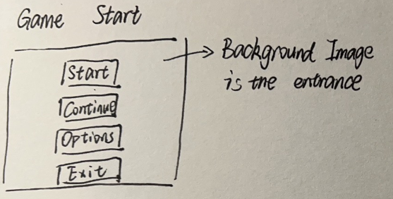

Figure Concept image of the main menu

#### Options Screen

On the options screen, players can adjust some basic game settings, including but not limited to, language, brightness, volume, and resolution.

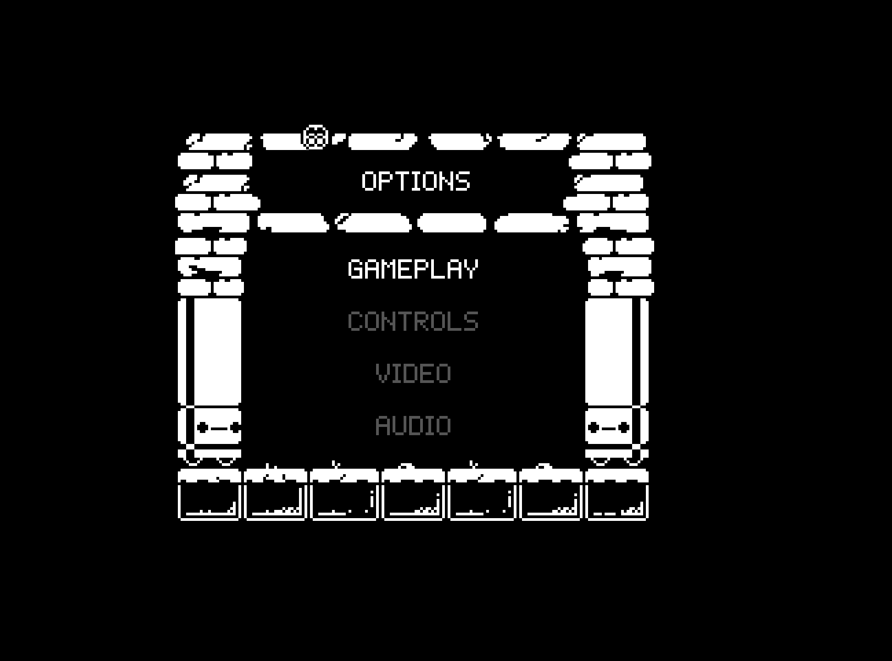

Figure An example image of the options screen

#### Game Screen

On the game screen, players will see the game in progress, which is the part they mainly participate in. In the upper left corner, some basic attributes of the player will be displayed, such as health points, and the number of gold coins held. In the upper right corner, it mainly displays the map of the player's current level. The lower right corner shows the weapon held by the player. Here is an example, but it does not represent the real situation of the game

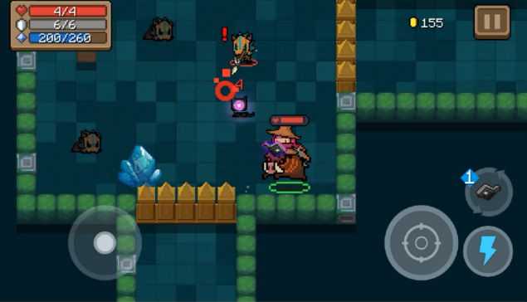

Figure Example image of the game screen

#### Game Over Screen

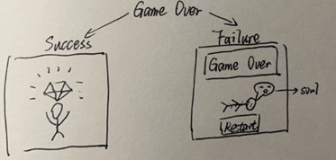

Figure Concept image of two types of the game over screen

#### Menu Screen in the Game

During the game, the player can call out the menu by pressing the ESC key, and the game will automatically pause at that time. In this screen, players can restore the game, adjust game settings, quit to the main menu, shut down the game, etc.

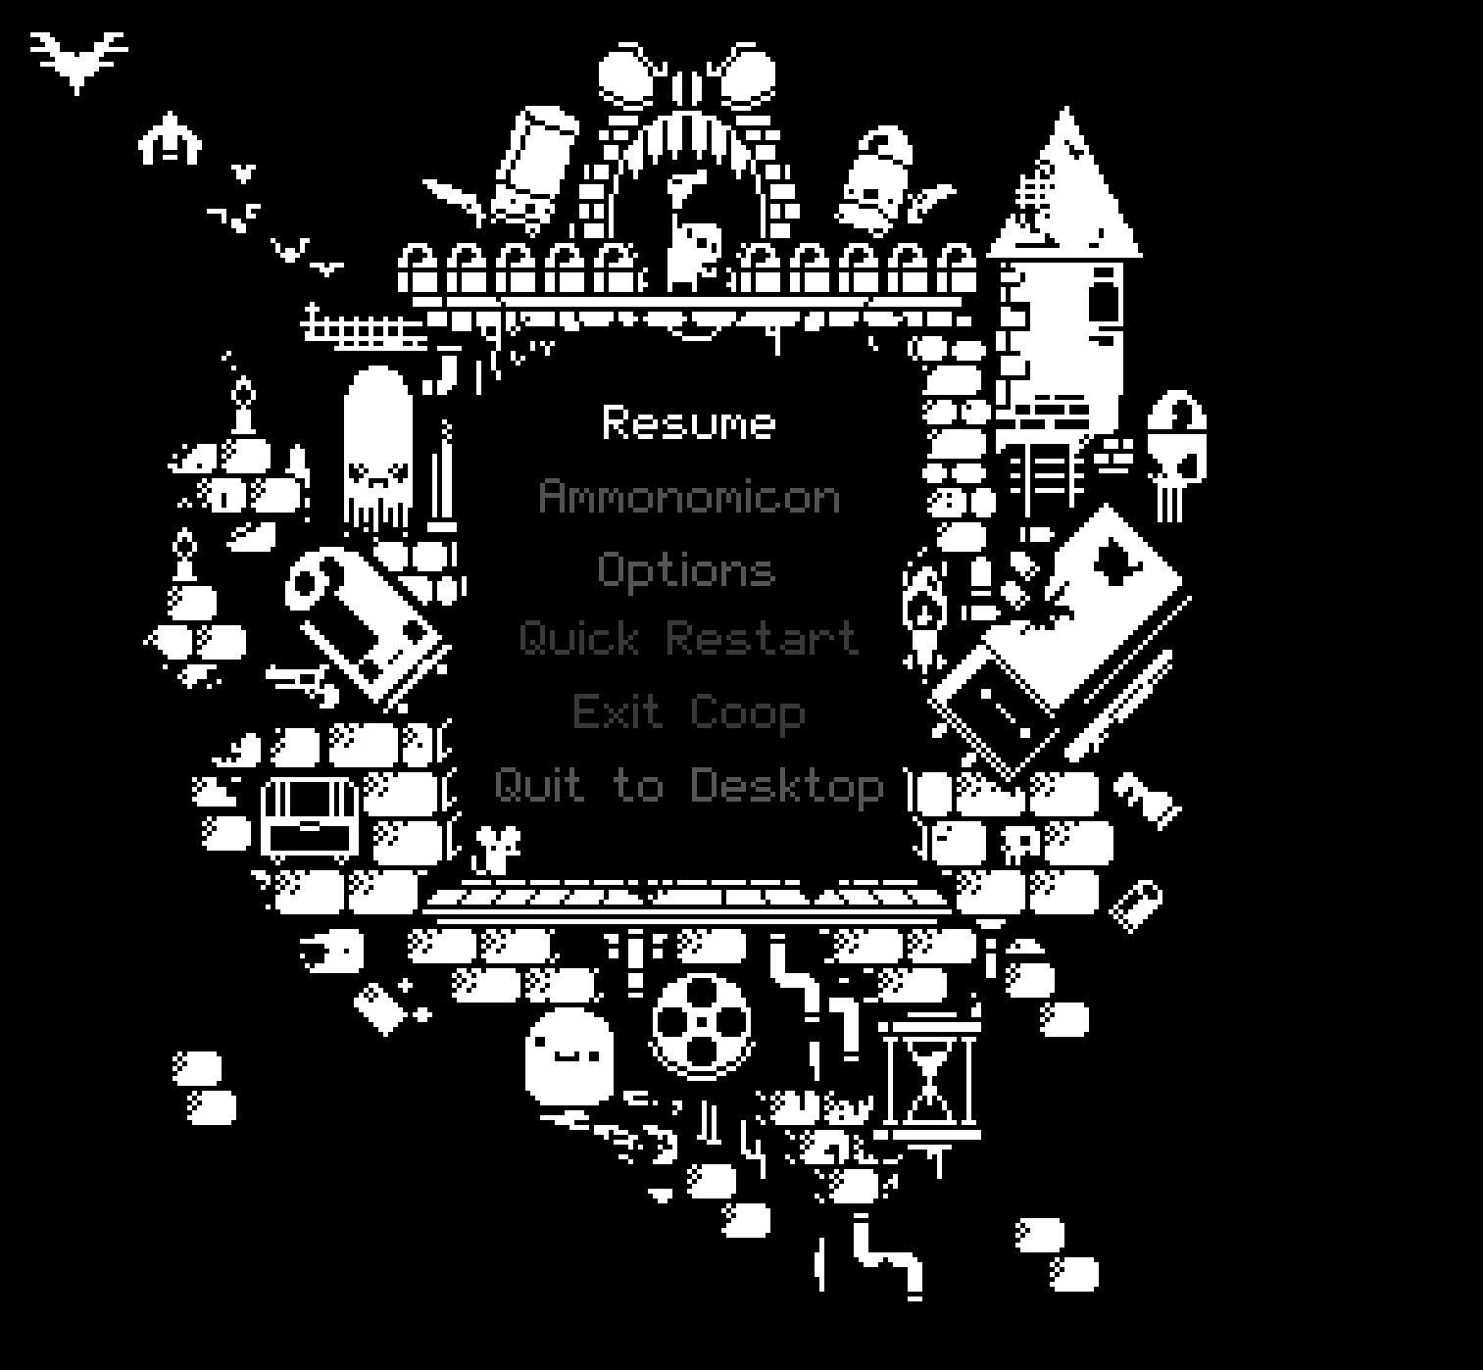

Figure Concept image of the menu screen in the game

## Game Options

(1) Volume: Players can adjust the volume of the game.

(2) Gamma: Players can adjust the brightness of the screen.

(3) Resolution: Players can adjust the resolution size of the game window

(4) Screen mode: Players can choose windowed, full screen or borderless mode

(5) Image Quality: Players can adjust the game quality based on the performance of their computer hardware

(6) Language: The native language of the game is English, and other languages may be added in the future

## Replaying and saving

The game keeps track of the number of levels the player has reached, and if they exit and re-enter, they will restart from that level.

## Cheats and Easter Eggs

There are no plans to include cheat codes. However, some backdoors may be set during the testing phase for the convenience of testing, but they will be deleted after the game is completed. Easter eggs will appear in the form of weapons or some special puzzle rooms.

# Story, Setting and Character

## Story and Narrative

### Back story

**Simple Version:** In a time of technology and magic, the magical stone protecting the world is stolen by some bad guys. The world is hanging on a thin thread. It all depends on you retrieving the magical gem.

**Complex Version:** The earth has been invaded by aliens. Scientists have selected a group of potential people and arranged for them to enter the virtual cabin for training. As one of them, whether the main role can successfully pass the training in the virtual cabin and wake up to save the world depends on you sitting in front of the screen.

### Game Progression

**Simple Version:** In this game, players must reach the bottom of the dungeon, defeat the final Boss and take back the magic gem. During the process of getting to the bottom, players need to complete each level and for each level, they need to complete each room. After entering any room with enemies, the doors will be closed. Only after all enemies have been eliminated, the doors of the room can be unlocked. Usually, a series of such rooms are experienced before reaching the level boss’s room. After defeating the level boss, they can enter the next level. Players will repeat this until they meet the final Boss. If they defeat the final Boss, they can enter the gem room to get the gem back, at this time game is successful. However, if players lose all health points before they enter the gem room, they need to restart the game from the entrance of the dungeon with nothing.

**Complex Version:** As the number of clearances and the number of dungeon expeditions increases, Players will gradually collect some special pieces of paper, which will form a sentence when they are fully collected. This will tell the players the truth about the dungeon, and the fully assembled note has magical powers that allow the player to resist the vortex generated after taking the gem back, thus putting the player into the final trip mode.

In the final trip mode, players can learn the truth about the dungeon, and they need to defeat the real final boss.

### License Considerations

## Game World

### General look and feel of the world

Top-down perspective, 2D, pixel.

### Area #1 – Entrance of Dungeon

(1) General Description: The entrance of dungeon and also is the start point of the game.

(2) Physical Characteristics: None special characteristics

(3) Levels that use area: Only at the beginning of the game.

(4) Connections to other areas: There is a dungeon entrance in this area

(5) Concept Image:

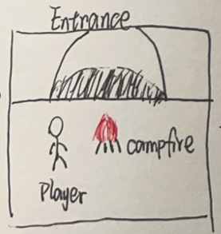

Figure Concept image of area #1

### Area #2 – Final Boss

(1) General Description: The final boss of the game.

(2) Physical Characteristics: There are some barriers in the boss room. Used to limit the player's movement space and facilitate the player to dodge the attack of the BOSS

(3) Levels that use area: Final Boss Level

(4) Connections to other areas: After defeating the final boss, a portal will appear, and players can be teleported into gem room after entering the portal.

(5) Concept Image

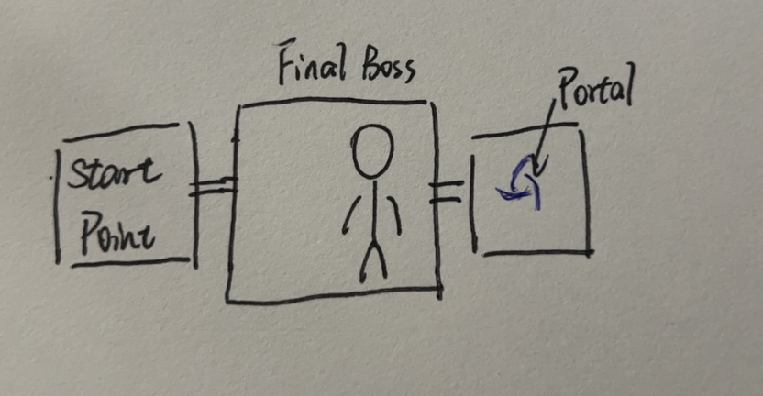

Figure Concept image of area #2

### Area #3 – Gem Room

(1) General Description: Deepest part of the dungeon, where the magic stone is stored.

(2) Physical Characteristics: No special characteristics.

(3) Levels that use area: Gem Level

(4) Connections to other areas: After touching the gem, the player will be teleported to the dungeon entrance if the condition is not met.

(6) Concept Image:

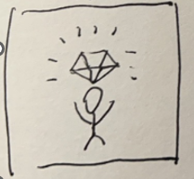

Figure Concept image of area #3

### Area #4 - Catacombs

(1) General Description: The main scene of the game level 1, 2, 3.

(2) Physical Characteristics: An underground cemetery consisting of a subterranean gallery with recesses for tombs, as constructed by the ancient Romans.

(3) Levels that use area: Level 1, 2 and 3

(4) Connections to other areas: After defeating the level boss, the player can enter the next level.

(5) Concept Image:

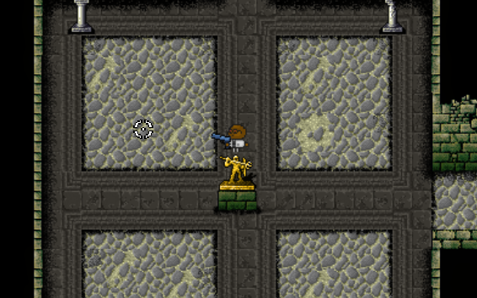

Figure Concept image of area #4

### Area #5 – Sorcery

(1) General Description: The main scene of the game level 4, 5, 6.

(2) Physical Characteristics: In a place full of witchcraft, there are failed products of witchcraft experiments everywhere, dark and damp.

(3) Levels that use area: Level 4, 5, 6

(4) Connections to other areas: After defeating the level boss, the player can enter the next level.

(5) Concept Image:

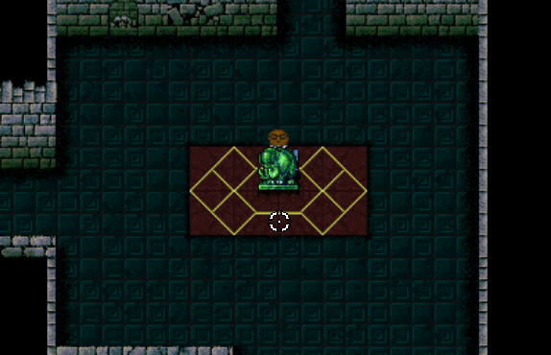

Figure Concept image of area #5

## Characters

### Character #1 – The general

1. Back story

He was a general who was chosen as a candidate to save the world after retiring from the military.

1. Personality

Steady, brave, reliable, smart, or some other personalities that a hero should have.

1. Physical characteristics

Old man with silver hair in green military uniform and black eye patch.



Figure Image of the general

1. Special Abilities

Higher shooting accuracy

1. Relevance to the game story

He is one of the candidates.

1. Relationship to other characters

They are all hero candidates to save the world.

### Character #2 – The scientist

1. Back story

An unknown scientist, in the process of his experiment, suddenly a group of people broke into his laboratory and sent him to a strange dungeon

1. Personality

Calm and analytical.

1. Physical characteristics

Bald middle-aged man in a white lab coat.



Figure Image of the scientist

1. Special Abilities

Currently not decided.

1. Relevance to the game story

He is one of the candidates.

1. Relationship to other characters

They are all hero candidates to save the world.

### Character #3 – The thief

1. Back story

A habitual thief, he was caught on his last theft. But instead of a prison, he was sent to a strange dungeon

1. Personality

Cunning, greedy, cowardly.

1. Physical characteristics:

Red-haired man in black with a black mask does not want to expose his face to others



Figure Image of the thief

1. Special Abilities

Higher movement speed, roll farther, roll faster, less roll cooldown.

1. Relevance to the game story

He is one of the candidates.

1. Relationship to other characters

They are all hero candidates to save the world.

# Technical

## Target Hardware

Minimum requirements to play this game:

(1) OS: Windows 7 or later

(2) Processor: Intel Core 2 Duo E6320 (2*1866) or equivalent

(3) Memory: 2 GB RAM

(4) Graphics Card: GeForce 7600 GS (512 MB) or equivalent

(5) Storage: 2 GB of available space required

## Development hardware and software

### Development hardware

My own laptop – Lenovo Legion Y9000P IAH7H, 12th Gen Intel(R) Core(TM) i7-12700H 2.30GHz, 16GM DDR5, RTX 3060

### Development software

Unity, VSCode, Git, etc.

## Development procedures and standards

### Development procedures

Agile methodology by the name of Scrum. Scrum is a process skeleton consisting of a set of practices and predefined roles. In each sprint (a 15-30 days cycle, the length of which is determined by the development team), the development team creates an increment of usable (ready to roll out) software. The features to be implemented in each sprint come from the product order. The product order (product goal) refers to the outline requirements of the work that needs to be completed in order of priority. Which line items (goal items) are included in a sprint is determined by the sprint planning meeting. In the meeting, the product owner tells the development team which line items in the product order he needs to complete. The development team decides how many line items they can commit to in the next sprint. During a sprint, no one can change the sprint backlog, which means that the requirements are frozen during a sprint.

In this project, each sprint is defined as 1-2 weeks based on the features to be implemented and the timetable.

### Development standards

No warnings or errors left after each commit. Comply with the C# code specification

## Game Engine

Unity. The engine can be used to create 3D and 2D games. It is particularly popular for iOS and Android mobile game development, is considered easy to use for beginner developers, and is popular for indie game development.

## Network

This game is offline. I won’t use any network-related packages.

## Scripting Language

C#. Generally, Unity game development uses C# as the main development language. Although Unity itself supports Unity (an extension of Java) and Boo (a language inspired by Python), in normal production practice, C# is still used as the main development language.

# Interface

## Visual System

### HUD

Heads up display will be displayed at the corners of the screen. The upper left corner will display the player's health and score. A minimap is displayed in the upper right corner. The lower right corner displays the weapons and ammo held by the player.

### Menus

The main menu will implement the following functions: (1) Selecting characters. (2) Start the game. (3) View the high score list. (4) Quit.

### Rendering system

Using universal render pipeline.

### Camera

Using cinemachine as main camera, the camera's target group includes player and cursor, which allows the game perspective to be locked on the player and also enables the player to look away from a certain distance.

### Light models

Using global light 2D provided by Unity.

## Control system

The player interacts with the game through the keyboard and mouse.

## Audio

No audio files have been added yet

## Music

No music files have been added yet

## Sound effects

No sound effect files have been added yet

# Artificial Intelligence

Haven't progressed to the part of implementing the enemy yet. I will use the A-Star algorithm as the enemy's pathfinding algorithm.

# Game Art

All materials in the game are 2D pixel style. Here are some examples.



Figure Game art example - character



Figure Game art example - weapon



Figure Game art example - enemy

# Management

## Schedule

### Prototype 1 – October and November, 2022

(1) Decide game concepts.

(2) Complete main design of the game.

### Prototype 2 – December, 2022

(1) Custom game map editor.

(2) Basic room prefabs.

(3) Automatic and random map generator.

(4) Three basic characters.

(5) Basic player control and operations.

### Prototype 3 – January, 2023

1. Add some interactive items.
2. Weapons.

(3) Minimap.

(4) Sound and light effects.

### Prototype 4 – to be continued

## Version control

The link to GitHub repository: [luoyangyuli2001/InfiniteDungeoner (github.com)](https://github.com/luoyangyuli2001/InfiniteDungeoner)

## Test

I will use my laptop to test my game. If possible, I will upload my game to the unity community, some players may come to play my game, and they may find some bugs in the game. At the same time, I will also share the game with my friends, let them help me test the game.

# Appendices

## Material source

So far, all the materials used in this game are free gifts in the Udemy course.

## References

### General references

Unity user manual: https://docs.unity3d.com/Manual/index.html

Unity script reference: https://docs.unity3d.com/ScriptReference/

### Udemy courses

Dungeon game development: https://www.udemy.com/course/unity-2d-dungeon-gunner-roguelike-development-course/learn/lecture/28588875#overview

## Project video log:

YouTube link: https://youtu.be/juH6IerigGE